Data Science Career Track

TAKE HOME CHALLENGE -

Ultimate Report

by Edward Franke

06/02/2019

Part 1 ‑ Exploratory data analysis

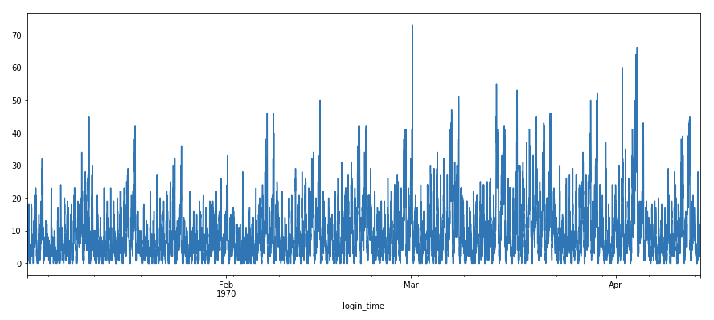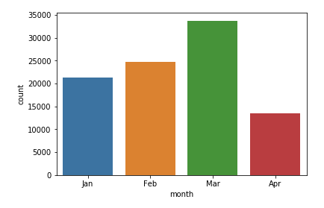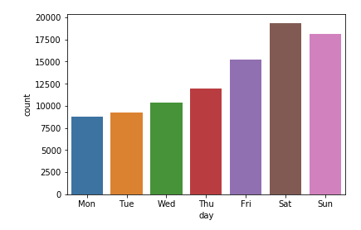

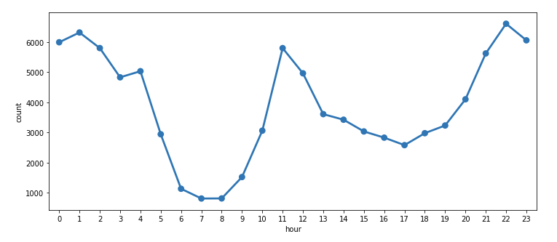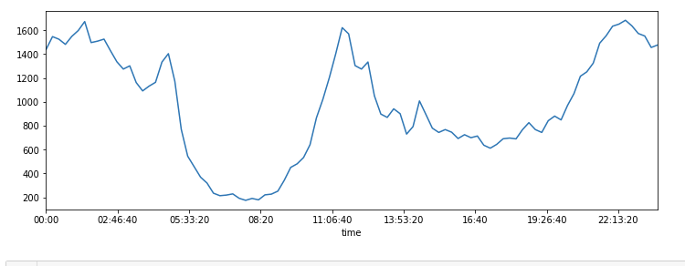

Part 2 ‑ Experiment and metrics design

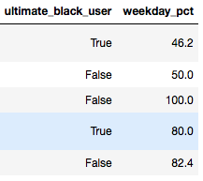

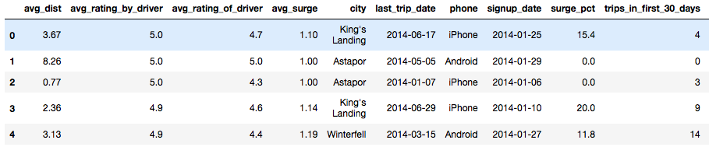



The neighboring cities of Gotham and Metropolis have complementary circadian rhythms: on

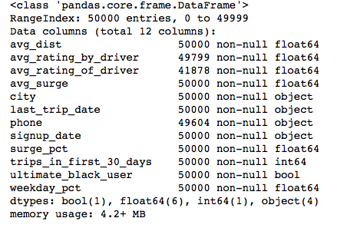

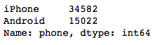

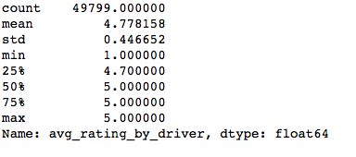

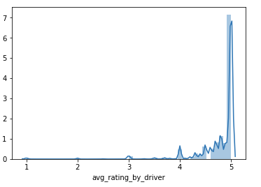

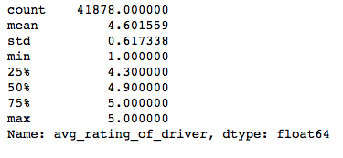

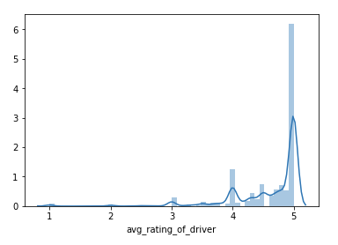

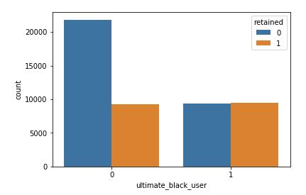

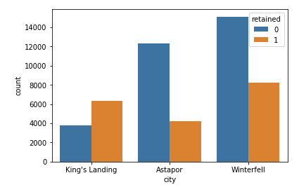

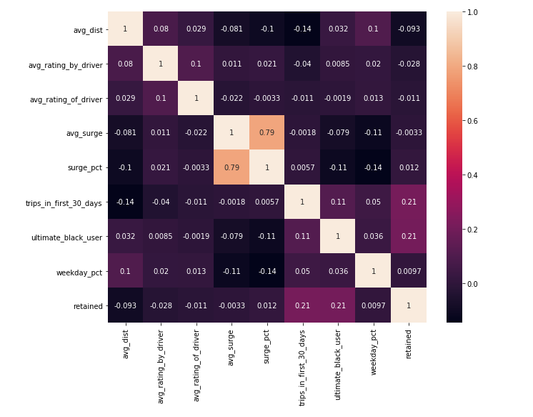

Part 3 ‑ Predictive modeling

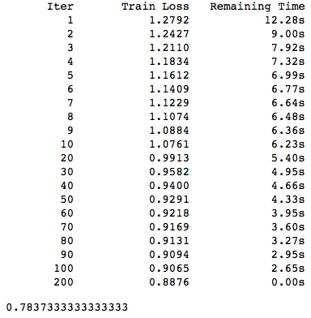

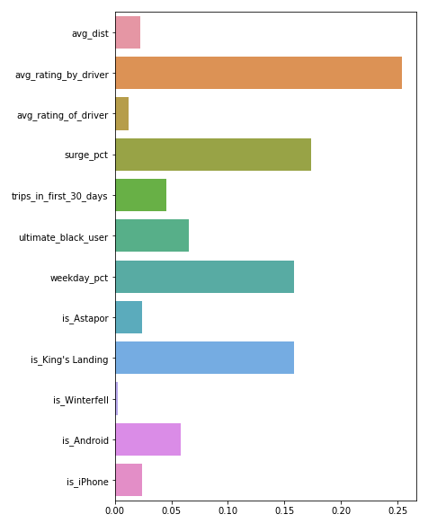

**OBSERVATIONS**

* Saturday is the most popular day for users followed by Sunday and Friday respectively. Monday shows the least activity.
* The login counts have been recorded from January 1, 1970 to April 13, 1970.
* the number of logins has progressively increased over the months. This indicates an increasing user base.
* Maximum activity between 10 PM and 1 AM. There is also a sharp rise in user activity at around noon. The least activity is recorded during early morning between 6 AM and 8 AM.

**RECOMMENDATIONS**

* Increase operations in King's Landing as they tend to have greater probability of conversion. Alternatively, discover what is unique about King's Landing drivers and passengers and check if it can be implemented in the other cities, especially Astapor.
* If the user has taken a Ultimate Black, it indicates that s/he is more likely to stay.
* Provide additional perks to these people.
* People who use cabs on the weekdays are more likely to be retained. This is the most important feature as discovered by the Gradient Boosting Classifier.
* Provide more offers in the weekdays to encourage people to take cabs to work.